**Agile, Git, and Beyond**

FSD: Lab Guide



| Note: Please do not alter the version of the tools as it might lead to incompatibility. |
| --- |

This section will guide you to:

* Use labs to execute all demos included in this course

This lab has two subsections, namely:

* + 1. Starting practice labs on LMS
    2. Using different IDEs and software

**Step 1:** Starting practice labs on LMS

* Login to Simplilearn LMS
* Go to the respective course

* On the left, you will find the course ToC page
* To its left, you will find the **PRACTICE LABS** tab
* Click on it

* As a new window opens, read the instructions and click on **LAUNCH LAB**
* This will launch practice labs for this course

* Click on Start Instance and select RPD Access

* You will be able to access IDEs and software which are present in labs

**Step 2:** Using different IDEs and software

**Git:**

* Git is already installed in the labs
* To check whether Git is installed properly or not:
  + Create a folder named **Demo_Git** on your desktop and open it
  + Create the files: index.html and helloWorld.java
  + Open the terminal and navigate to the folder you have created
  + Execute the following command to initialize git repository:

*git init*

**MySQL:**

* MySQL is already installed in your practice labs
* To verify the installation:
  + Open the command-line interface
  + Type the following command:

*mysql -V*

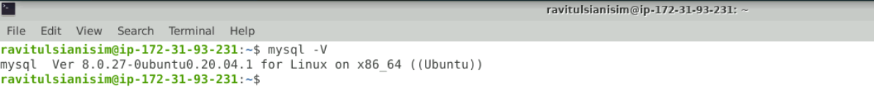

The command mentioned above displays the MySQL version installed in your practice labs

* In case you find that MySQL is not installed in your practice labs, you can install it using the following commands:

*sudo apt-get update*

*sudo apt-get install mysql-server*

**Angular:**

* Angular has been installed in your practice labs using *npm*
* To verify the installation:
  + Open the command-line interface
  + Type the command:

*ng --version*

* In case Angular is not installed in your practice lab, you can install it using the command:

*sudo npm install -g @angular/cli*

**Cucumber:**

* Cucumber is installed as an Eclipse plugin in your practice lab
* To verify the installation:
  + Open the Eclipse environment from your desktop
  + Click the **Help** tab and select **Install New Software**

* In the next window, click on **Already Installed**

* In the **filter text** field, type **Cucumber**

* In case Cucumber is not installed in your practice lab, you can install it following these steps:
  + Open the Eclipse environment from your desktop, navigate to the **Help** tab, and click on **Eclipse Marketplace**

* + Type **Cucumber** in the **Find** field and click on **Go**
  + In the next window, you will see the Cucumber tool
  + Click on the **Install** button it to start the installation

**Core Java:**

* Java is already installed in the labs
* Open the terminal and type **java** to find whether Java is installed or not

* If Java is not installed in your system, then

            Type the following commands:

*sudo apt-get install openjdk-8-jdk*

*sudo apt-get install openjdk-8-jre*

**Maven:**

Maven is already installed in your practice labs

* You can use the following command to verify the installation:

*mvn -v*

* In case Maven is not installed in your system, you can install it using the commands:

*sudo apt-get update*

*sudo apt install maven*

**MongoDB:**

* To verify the installation:
  + Open the command-line interface
  + Type the command:

*mongod --version*

* In case MongoDB is not installed in your practice lab, you can install it using the commands:

*sudo apt-get update*

*sudo apt-get install -y mongodb-org*

*sudo apt install mongodb-server-core*

**JUnit:**

JUnit is already installed in your practice labs as a .jar file,and you can find it in the directory */usr/share/java*

* Use the following command to navigate to the above-mentioned directory:

*cd /usr/share/java/*

*ls*



* In case JUnit is not installed in your practice lab, you can install it using the command:

*sudo apt-get install junit*

**Spring Tool Suite & Spring Boot:**

Spring and its packages are already installed in your practice labs

* To verify the installation:
  + Open the Eclipse environment from your desktop
  + Go to the **Help** tab and select **Install New Software**

* In the next window, click on **Already Installed**

* + In the **filter text** field, type **Spring**

* In case Spring packages are not installed in your practice lab, you can install them following these steps:
  + Open the Eclipse environment from your desktop, go to the **Help** tab, and click on **Eclipse Marketplace**

* + Type **Spring** in the **Find** field and click on **Go**
  + You’ll find Spring Tool Suite and Spring Boot listed there
  + Click on the **install** button against the package that you want to install

**Docker:**

* Docker version 20.10.11 is already installed in your practice lab
* To verify the installation:
  + Open the command-line interface
  + Type the command:

*docker --version*

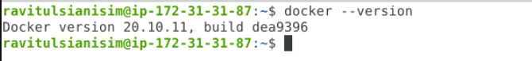

* In case Docker is not installed in your practice lab, you can install it following these steps:
  + Set up the Docker repository using the following commands:

*sudo apt-get update*

*sudo apt-get install apt-transport-https ca-certificates curl software-properties-common*

*curl -fsSL https://download.docker.com/linux/ubuntu/gpg | sudo apt-key add –*

*sudo add-apt-repository "deb [arch=amd64] https://download.docker.com/linux/ubuntu $(lsb_release -cs) stable"*

* + Install Docker using the command:

*sudo apt-get install docker-ce*

**AWS:**

* AWS is already installed in your practice labs

*aws --version*



* In case JUnit is not installed in your practice lab, you can install it using the command:

*sudo apt-get install awscli*

**Jenkins:**

* Jenkins is already installed in your practice labs

* You will find it in the directory */usr/share*

* Use the following commands to navigate to the above-mentioned directory:

*cd /usr/share*

*ls*



* In case Jenkins is not installed in your practice lab, you can install it using the commands:

*sudo apt update*

*sudo apt install jenkins*